**LAB # 2**

**Python Programming II**

**Introduction**

Python is a powerful high-level, object-oriented programming language created by Guido van Rossum. It has simple easy-to-use syntax, making it the perfect language for someone trying to learn computer programming for the first time. This is a comprehensive guide on how to get started in Python, why you should learn it and how you can learn it.

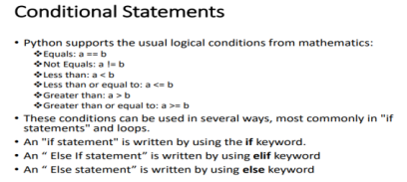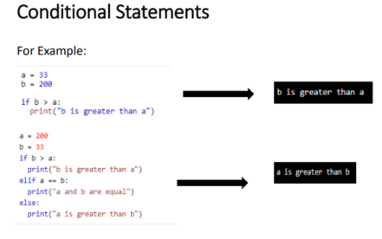

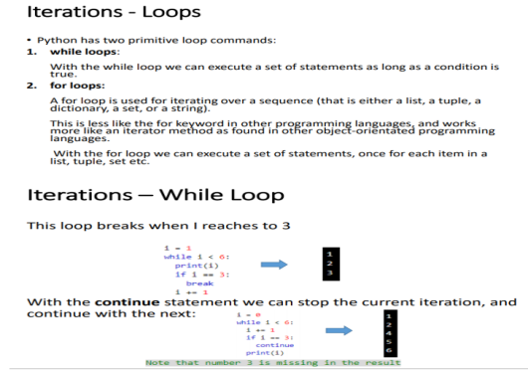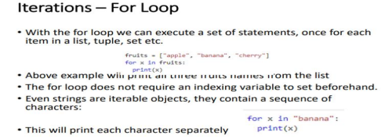

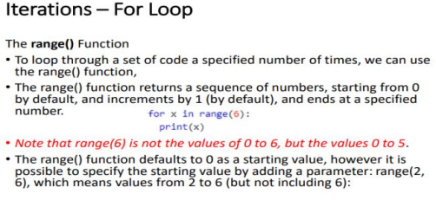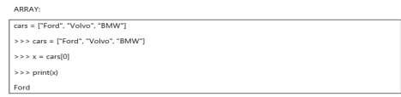

: grade = input("Enter your grade: ")

if grade >= 90:

print("A")

elif grade >= 80:

print("B")

elif grade >= 70:

print("C")

elif grade >= 65:

print("D")

else:

print("F")

EXAMPLE:

Lab Task:

1. Give an array length 1 or more of ints, return the difference between the largest and smallest values in the array. Note: the built-in-min(v1,v2) functions return the smallest or larger of two values.

**Sample Run:** 1,2,3,4,5,8,9,10,15,40,3

**Input: min = 1, max = 40 difference =39**

Return the number of times that the string “ant” appears anywhere in the given string, except we’ll accept any letter for the ‘n’, so “art” and “abt” and other counts

**Sample run**

**String:** Antandart

**Output: count = 2**

**Code**

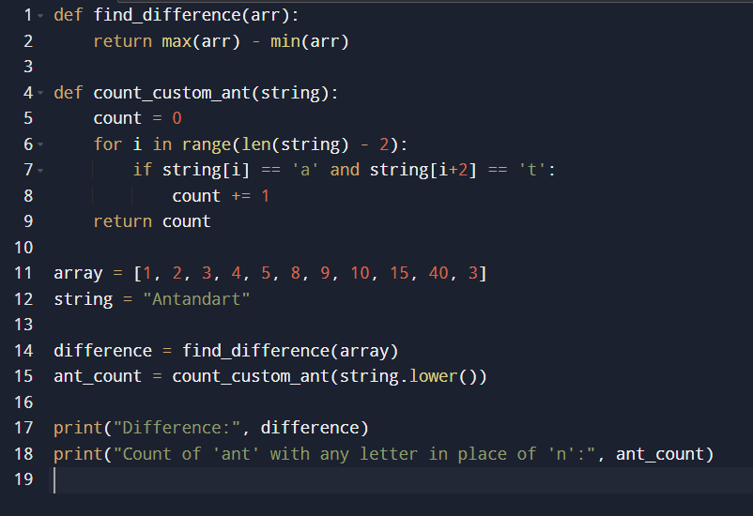



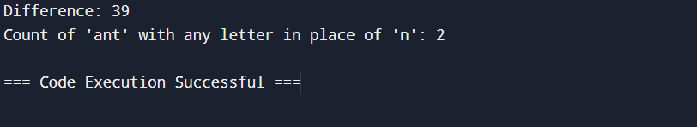Output